**一、路由配置相关**

1.安装’react-router-dom’，引入并结构{Route,HashRouter,Switch}

import { Route, HashRouter, Switch } from 'react-router-dom'

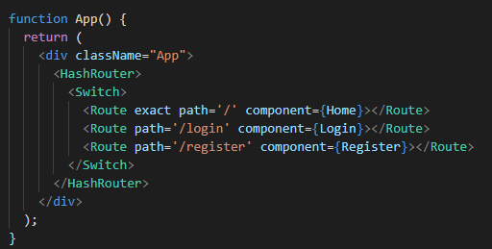

1. 安装’react-loadable’并引入（懒加载）

import Loadable from 'react-loadable'

